Dear Colleague:

On behalf of the Aerospace Professional Staff Association (APSA), I would like to invite you to join APSA.

During your original orientation at Aerospace, you were briefly told that APSA is the professional organization representing the non-supervisory Members of the Technical Staff (MTS) at Aerospace, and that APSA negotiates an annual agreement with the Corporation on your behalf. Because of APSA, you are a “just cause” employee, not an “at will” employee.

The formal Agreement between the Corporation and APSA is extremely important because it governs the terms and conditions of your employment at Aerospace. The Agreement provides for a working environment more conducive to your well-being thus allowing you to concentrate your personal efforts toward enhancing your own career development within the Corporation.

Historically, engineers and scientists have tended to be individualists. However, many of our colleagues came to realize that, as individuals, we cannot have much influence on the size of the raise pool or on whether the benefits package will be improved or even maintained in its present makeup. Consequently, in 1974 concerned employees formed APSA, which has been effective in making Aerospace a better and more rewarding place to work.

But the continuation of our effectiveness, particularly in our annual negotiation with the Corporation, requires constant replenishment of our membership as people retire or leave the Corporation for various reasons. We encourage you to support APSA directly by becoming a member. Incidentally, APSA members enter management at a rate higher than the rate for the overall non-supervisory MTS population. The form to apply for APSA membership is on the back of this letter. As a member, you will be automatically provided with a copy of the annual agreements, MTS salary statistics, APSA bulletins, and you will have the opportunity to participate and vote on APSA business matters. APSA welcomes all non-supervisory MTS at our quarterly General Membership Meetings in building A1 or by conference call-in.

If you have questions about APSA or if I can be of any help, please call me at (310) 336-0159. Again, your colleagues need your support!

Sincerely,

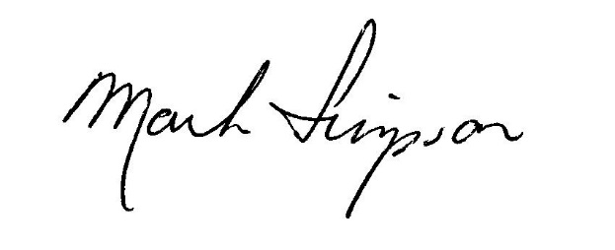

Mark M. Simpson
President
To join APSA, please complete this membership application and dues deduction authorization form and return it to APSA, Attn: Richard Mahoney at M4/933, or by U. S. mail at the address below. No cash is required. Dues for full-time employees are $3.25/week or $169/year. Dues for part-time employees are half the full-time amount, which APSA collects by direct billing.

If you prefer to pay your dues directly to APSA rather than through payroll deduction, write across the authorization form "Prefer direct payment to APSA", sign and return with your membership application. APSA will bill you annually. Dues are pro-rated for applications during the year.

=================================================================================

AEROSPACE PROFESSIONAL STAFF ASSOCIATION (APSA)
P.O. Box 248, Hawthorne, California 90251-0248

I do hereby apply for membership in APSA and agree to pay dues as voted by the membership.

Signed:_____________________________________ Date:_______________

____________________________________________________________________________________________
Last name First Middle Home phone

____________________________________________________________________________________________
Mailing Address City Zip Code

____________________________________________________________________________________________
Employee No. CCC Bldg./Room Mail Station Office phone

____________________________________________________________________________________________
Degree Specialty Hire Date Full-time/Part-time

____________________________________________________________________________________________
Professional Societies and Professional Licenses

____________________________________________________________________________________________
Name of referring APSA member, if applicable

=================================================================================

DUES DEDUCTION - AUTHORIZATION AND ASSIGNMENT

Name:____________________________________________________________________
Last First Middle

_____________ ______________________
CCC Employee No.

TO THE AEROSPACE CORPORATION (Herein called the Company)

1. You are hereby authorized:
a. To deduct from my salary each week a sum equivalent to the amount which shall have been certified by the Aerospace Professional Staff Association (APSA) as the weekly portion of its regular annual membership dues.
b. To remit all sums so deducted to the Treasurer of the Association.
2. This authorization may be revoked by giving written notice thereof to APSA for forwarding to the Company, provided, however, that the Company shall be allowed up to four (4) weeks to implement such revocation after the week in which the Company receives such notice.
3. This authorization supersedes any prior authorization.

Date:__________________ __________________________________________________
Employee Signature

